HOUSEHUNT
House Rental Management System
Full Stack Development with MERN
Project Documentation

1. Introduction
Project Title:
HouseHunt - House Rental Management System
Team Members:
Name | Role
Bhavita Ganji | Full Stack Developer

2. Project Overview
Purpose
HouseHunt is a web-based House Rental Management System developed using the MERN Stack (MongoDB, Express.js, React.js, and Node.js).
The main objective of the project is to simplify the process of listing, managing, and booking rental properties through a centralized online platform. Property owners can add and manage properties, while renters can browse available properties and submit booking requests.
Features
- User Registration and Login
- JWT-Based Authentication
- Role-Based Access Control
- Owner Dashboard
- Add Property Functionality
- View Property Listings
- Renter Dashboard
- Browse Available Properties
- Submit Booking Requests
- MongoDB Atlas Integration
- RESTful API Architecture

3. Architecture
Frontend Architecture
The frontend is developed using React.js and React Router DOM.
Major Components:
- Home Page
- Login Page
- Registration Page
- Owner Dashboard
- Renter Dashboard
- Admin Module
- Property Management Pages
Axios is used to communicate with backend APIs.
Backend Architecture
The backend is developed using Node.js and Express.js.
Main Components:
- Routes
- Controllers
- Middleware
- Models
Responsibilities:
- Handle API Requests
- User Authentication
- Database Operations
- Property Management
- Booking Management
Database Architecture
MongoDB Atlas is used as the cloud database.
Collections:
Users Collection
Stores:
- Name
- Email
- Password
- User Type
Properties Collection
Stores:
- Property Information
- Owner Details
- Property Availability
Bookings Collection
Stores:
- Booking Requests
- Property Information
- User Information

4. Setup Instructions
Prerequisites
Install:
- Node.js
- npm
- MongoDB Atlas Account
- Visual Studio Code
- Git
Installation
Step 1: Clone Repository
git clone <repository-url>
Step 2: Install Frontend Dependencies
cd client
npm install
Step 3: Install Backend Dependencies
cd server
npm install
Step 4: Configure Environment Variables
Create a .env file inside the server directory.
MONGO_URI=your_mongodb_connection_string
JWT_SECRET=your_secret_key
PORT=8000

5. Folder Structure
Client Structure
client
│
├── public
├── src
│ ├── modules
│ │ ├── common
│ │ ├── admin
│ │ └── user
│ ├── App.jsx
│ └── main.jsx
Server Structure
server
│
├── controllers
├── routes
├── models
├── middleware
├── config
└── server.js

6. Running the Application
Backend
cd server
node server.js
Server runs on:
http://localhost:8000
Frontend
cd client
npm run dev
Frontend runs on:
http://localhost:5173
7. API Documentation
User APIs
Register User
Endpoint
POST /api/users/register
Request
{
"name":"Bhavi",
"email":"bhavi@gmail.com",
"password":"123456",
"type":"owner"
}
Response
{
"message":"User registered successfully"
}

Login User
Endpoint
POST /api/users/login
Request
{
"email":"bhavi@gmail.com",
"password":"123456"
}
Response
{
"token":"jwt_token"
}

Property APIs
Add Property
POST /api/properties/add
Get Properties
GET /api/properties

Booking APIs
Create Booking
POST /api/bookings
View Bookings
GET /api/bookings

8. Authentication
Authentication is implemented using JSON Web Tokens (JWT).
Workflow:
- User registers an account.
- User logs in using email and password.
- Password is verified using bcrypt.
- JWT token is generated.
- Token is stored in localStorage.
- Protected routes are accessed using authentication middleware.
Authorization is role-based:
- Admin
- Owner
- Renter/User

9. User Interface
The user interface is developed using React.js.
Major Screens:
- Home Page
- Login Page
- Registration Page
- Owner Dashboard
- Add Property Page
- Renter Dashboard
- Property Listing Page
- Booking Page
10. Testing
Testing was performed using manual functional testing.
Test Cases Covered:
- User Registration
- User Login
- JWT Authentication
- Property Addition
- Property Retrieval
- Booking Requests
- Database Connectivity
- Route Navigation
Expected and actual outputs were verified successfully.

11. Screenshots or Demo
Home Page
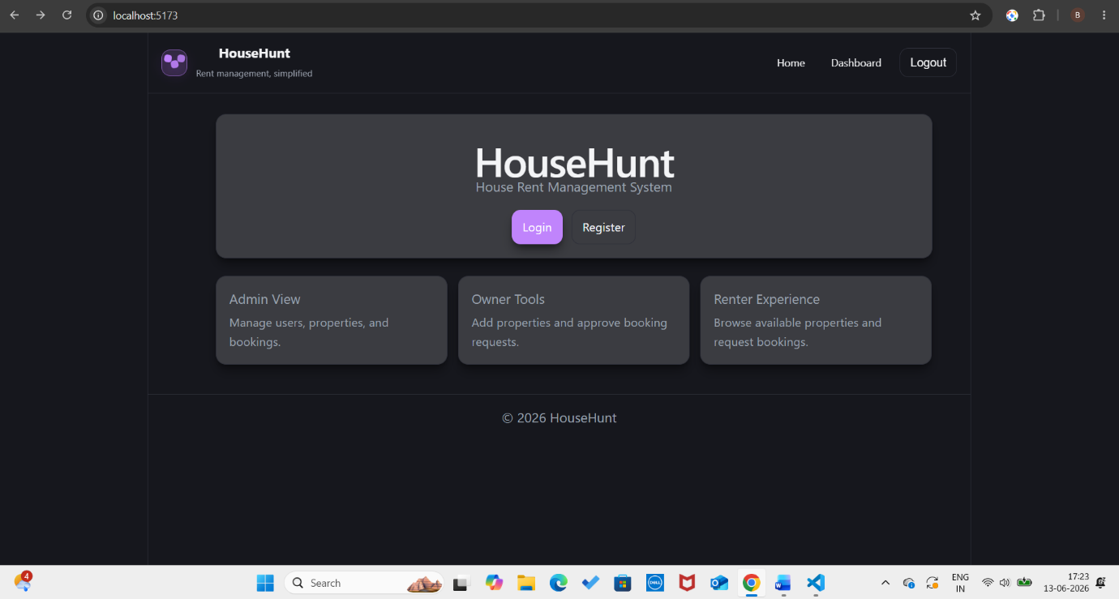
Login Page
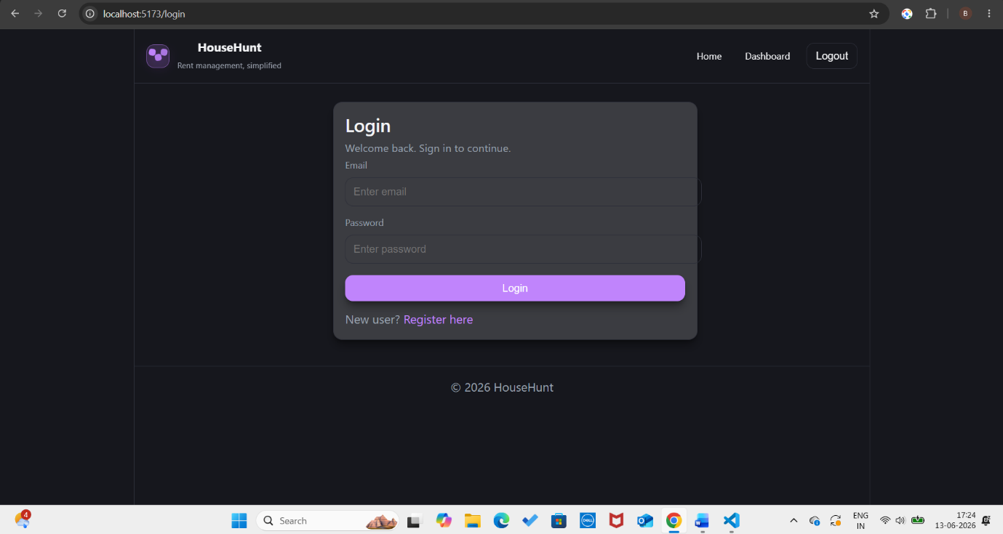

Registration Page
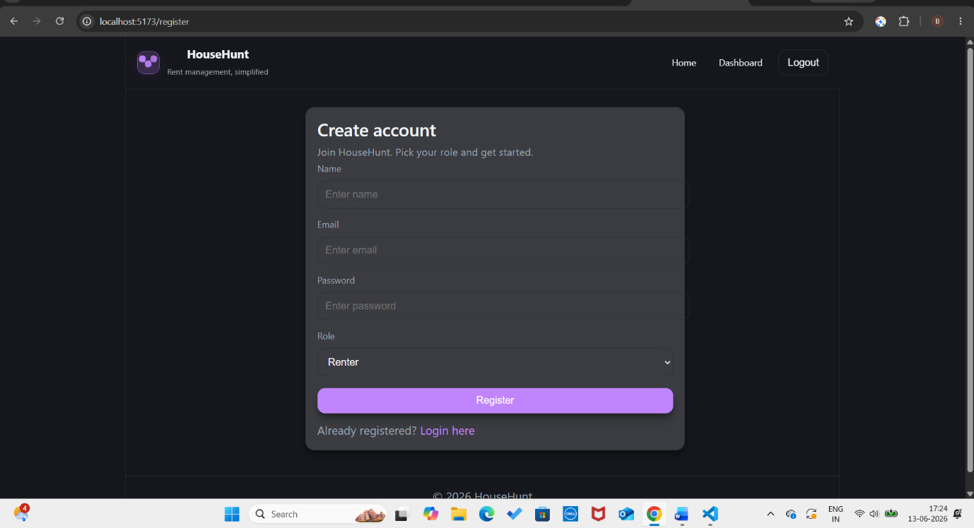
MongoDB Atlas
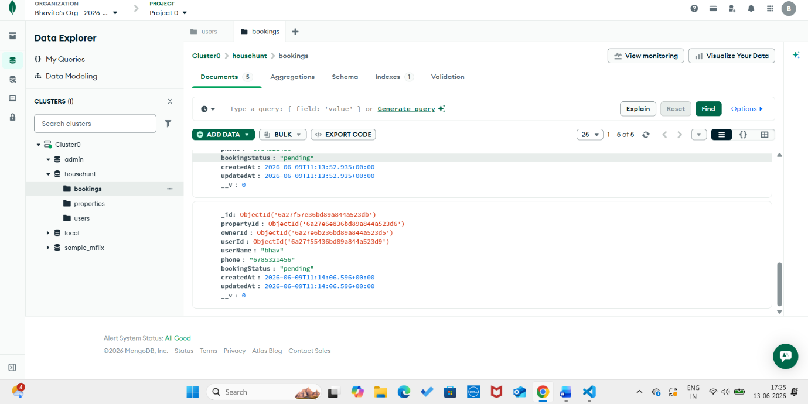
GitHub Repository Link:
https://github.com/bhavita-ganji/HouseHunt
Link to the demo:
https://drive.google.com/file/d/1XYEqDrLNgmzFuA8u6OYKP2Iqj5fbYuMr/view?usp=drive_link

12. Known Issues
- Admin module requires additional testing and integration.
- Property image upload functionality is not yet implemented.
- Search and filter functionality can be enhanced.
- UI responsiveness can be further improved.

13. Future Enhancements
Future improvements include:
- Property Image Upload
- Advanced Search and Filtering
- Google Maps Integration
- Email Notifications
- Payment Gateway Integration
- Chat Between Owner and Renter
- Property Reviews and Ratings
- Mobile Responsive Design Improvements
Conclusion
HouseHunt is a full-stack MERN application that demonstrates modern web development concepts including React frontend development, Express backend APIs, MongoDB database integration, JWT authentication, CRUD operations, and role-based access control.
The project successfully provides an online platform for property owners and renters while following the MERN architecture.

